

# GDD

### 

### Conestoga Traffic 2.0

### May 25, 2022

## Project Overview & Flow

Almost 2 years ago XpertVR collaborated with Conestoga College to create the Traffic Collision simulation. This simulation was an amazing leap forward in police foundations training content: the scenario allowed students to use all of the tools and techniques they would use in the real world to investigate a crime scene.

That being said, one major investigative tool was missing: communication. More specifically the ability to communicate with the drivers/victims of the collision, as well as witnesses and other emergency responders, to better understand the scenario and investigate the scene further.

XpertVR recently created a Conversation Matrix Tool (CMT). The CMT allows VR users to have decision tree based conversations with avatars in any virtual environment, while still having all of the other required functionality for the simulation. In this expansion of the existing project, XpertVR will be implementing the use of avatars who can be interviewed.

### Hardware & Platform Considerations

Builds will be made for PC and SteamVR - headset; Vive Cosmos.

### Learning Goals & Outcomes

• Create a roster of varied avatars to gather information from so students can practice their

communication skills

• Integrate an unlockable information system so that students can unlock more questions

through investigating the collision or vice versa unlock new clues through the conversations

• Prepare students to follow industry standards in investigating collision scenes, while also

having the communication skills necessary to exceed

## User Flow

VR and PC *Conestoga Traffic (Uplift)* users will both begin their simulation experiences by loading into a main menu environment, where they must interact with a user interface (UI) via the cursor or the VR UI interaction system. The first menu page will include text field prompts for the user to input their name and email to receive data results upon completing a scenario. The following main menu page is a scenario selection page with descriptions and corresponding selection buttons for:

* Tutorial Mode
  + Users are blocked off from leaving a specified radius around them with yellow wooden traffic barriers. Voice lines, paired with a player-paced tutorial sequence, step the user through every tool needed to complete each scenario as correctly as possible. The steps begin with the basics of control such as locomotion or movement controls (i.e. teleporting positions in VR vs. using the WASD keys on PC) then further tutorializing the user on how to use other necessary tools such as the tablet, camera, menu systems, measuring tool, CMT functionality, PC/VR specific functionalities, etc.
* Normal Mode
  + The user is dropped into 1 of 3 different scenarios, within 3 similar T-junction environment layouts, differing in time of day, weather conditions, stop signs vs. stop lights, etc. The user is prompted with a voice line reminding trainees that it is very important to protect the scene of the collision for the sake of evidence preservation and general investigation. They are then reminded to take pictures of anything that they believe could assist in determining what happened and how, such as open drugs and/or alcohol as well as point of impact related images (skidmarks, damage, etc.). The first time they interact with the photo button, the measurement button, or the CMT button, they are once again prompted with more voice lines advising on how to proceed with gathering evidence with the aforementioned tools. Once all the measurements have been made, photos have been collected, witness statements have been taken, driver information documented, and the trainee/user selects the “I’m Done” button they will then spawn in a results scene environment where they can view their photo gallery as well as a birds-eye-view of the accident where measurement lines are visible and access to dialogue from witness statements. From here they hand in their results and await email data collection. From the results scene you can navigate back to the main menu.
* Hard Mode
  + The user is dropped into 1 of 2 different scenarios, within 2 somewhat similar T-junction environment layouts. Systematically speaking, the functionality of normal and hard mode don’t differ much from one another beyond this point other than investigative complexity regarding witness statement CMT interactions along with environmental/contextual evidence present or involved within said hard mode scenario.
* New Environment Mode
  + The user is dropped into 1 of 3 different scenarios, within 3 similar highway on-ramp environment layouts, differing in time of day, weather conditions, etc. Systematically speaking, the functionality of the new environment mode vs. the normal and hard modes again, don’t differ much from one another beyond the obvious environmental alterations, along with new evidence pieces, CMT character interactions, as well as a new car make/model, all altering the difficulty level relative to the trainee and their ability to deal with new/different environmental factors.

## 

## Systems

### Conversation Matrix T00l (CMT) & Ready Player Me (RPM) Characters

Using the CMT along with physically represented RPM character models (See Art for examples), each witness and driver from each scenario will stand and wait at a designated position for the user to take a statement from them in whatever order they so please. The original Traffic Collision simulation’s text based witness statements will be replaced with this new witness interaction system where trainees approach all the available/reputable witnesses who can offer branching and unlockable dialogue options (see below) to further the user's understanding of the investigation. All dialogue is saved and journaled to reference later within your tablet and results scene.

### Unlockable Information System

This system involves the user being able to unlock previously inaccessible CMT dialogue options from specific driver and/or witness conversations. Dialogue options are unlockable either by finding key evidence pieces throughout a scenario and presenting them as evidence to a RPM character or a vice versa effect where what someone says may lead to you finding more evidence and so on. This could potentially lead users to unlock more previously undisclosed information to add to their witnesses statement as well as your general investigative findings.

### Menu UI Systems

The Menu UI System works directly with the SimulationManager to help users instigate level loading through scenario selection, adjust settings, and interface with the simulation in general. Additionally, this system is used to ensure that there is a complete and utter uniformity in regards to colorscheme, UI, and UX between all Conestoga policing VR/PC training simulations. The menu UI systems help manage all user interfaces throughout the simulation and extend to the tablet UI functionality as well. Tablet UI will be utilized to allow the user to begin or return to a CMT conversation between them and any other NPC/RPM character from any scenario.

### API Persistent Scene loading for PC

The SimulationManager is a built-in system within the XpertAPI that is not yet a part of the PC side of this project. Importing and including this will ensure more uniformatey between the PC and VR branches of the project whilst also increasing development efficiency. Developers will be able to load into any scene and test it rather than starting from the main menu every time. The XpertAPI also includes more quality-of-life settings and upgrades for developers and end users alike.

## 

## Art

### Art Direction

The general art direction for this project, in regards to scenario/environmental artistic design and style, would be identical to that of the previous traffic simulation. As mentioned above, the only addition or update to the art direction would be through the new Menu UI System and therefore will require some artistic and technical design/planning to ensure the UI is aesthetically satisfying and easily usable (See UX/UI Design).

### Environments

#### Environment 1 - T-intersection from first Traffic Sim

The reason for this environment being a T-intersection was because it’s an incredibly versatile instrument in studying and training for traffic collisions. T-intersections can have stop signs, yield signs perpendicular to right-of-way signs, as well as stop lights all with different combinations of weather and time of day conditions.

#### Environment 2 - New environment’s highway on-ramp

The new highway on-ramp environment is an important juxtaposition to the T-intersection as it presents a different set of rules, priorities, and considerations, all whilst upkeeping safety standards and focusing on completing the task at hand. Traffic collisions can happen in many different places and it’s important to remain diligent and agile while managing sometimes extremely high stake situations.

### 

### Scenarios

Dangers/Distractions for all scenarios:

S1 - Weather Conditions

S2 - Cell Phone

S3 - Makeup

S4 - Fallen Tree and weather

S5 - Late night driving

S6 - Insomnia and/or exhaustion

S7 - Weather Conditions and Distracted driving

S8 - Cell phone, earbuds, and food/drink

#### Environment 1

## Scenario 1 - Snow, Single Car, Traffic Light Crash

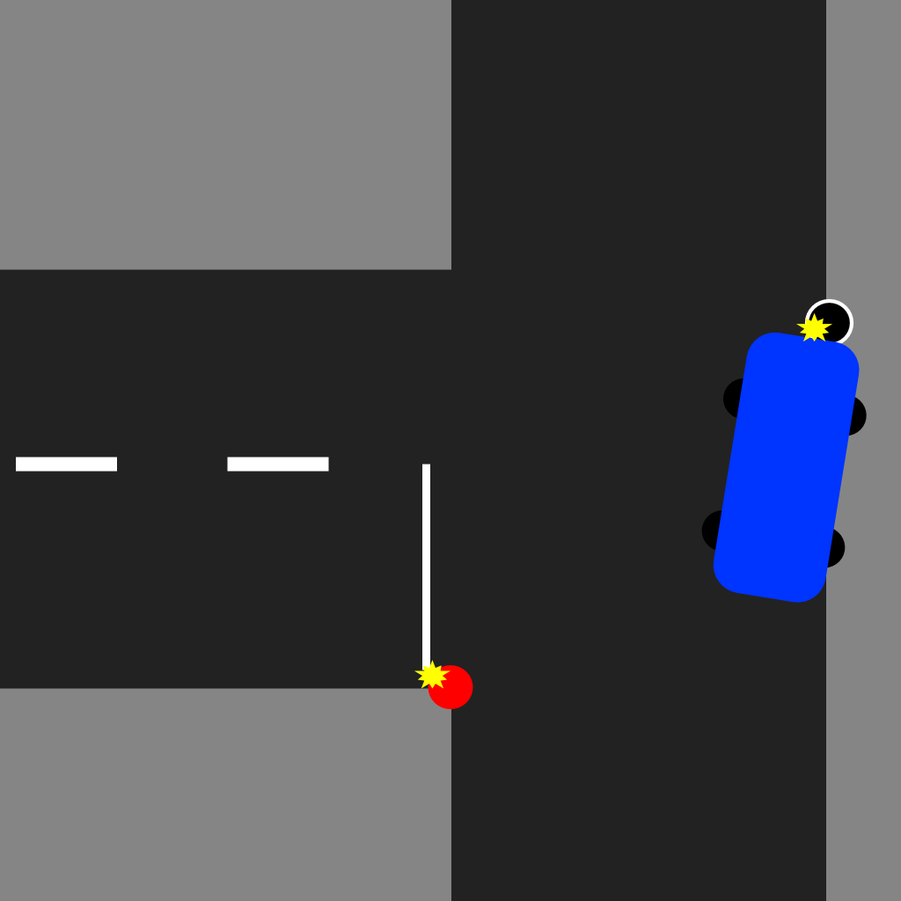

Storyline: Driver failed to stop at the red light due to snow, making the road very slippery, they could not stop and crashed into the traffic light on the other side.

**Speed at point of impact - ~35km**

**Weather conditions - Snow, Morning**

**Date and Time - Jan 21, 7:15 AM 2020**

Name of Offence

**Red Light – Fail to Stop**

Potential Evidence:

Smashed front bumper of car + front lights

Airbag deployed

Skidmarks

Dispatch Call: Attention all units, can you respond to a single vehicle collision at Grand River Street and Service Road 67. A vehicle has slid into a traffic light pole. It looks like the vehicle slid into the pole after failing to stop at the traffic light.

Michelle E. Oliverio, Driver: “It was dark and I didn’t see the intersection coming up. When I saw the red light, I tried stopping but it was too late. It was slippery, and I slid right through the light. I couldn’t stop, and I hit the traffic light pole.”

**Driver Biography**

Name: Michelle Oliverio

Address: 712 General Drive, Kitchener ON N2K 1R2

Licence #: O0095-69796-60119

Province: ON

Licence Class: G

Licence Issue Date: 2016/02/03

Licence Expiry Date: 2021/02/03

Condition:

Sex: Female

Birthdate: January 19, 1966 (55 yr)

Phone #: 905 975-5048

**Ownership**

Name: Michelle E. Oliverio

Address: 712 General Drive, Kitchener ON N2K 1R2

Plate # GTLQ-887

Year # 2016

Make: Audi

Model: AS3

VIN: JJ2HT6FEJ72579

Permit Number: O8861209

RIN # (Licence #):

Body Type: SUV

Type of Vehicle: (Always Passenger)

**Insurance**

Year Make Model: 2016 AUDI AS3 Hatchback

Policy # D38317208LRC

Insurance Company: Aviva

Phone Number: +1 800-387-4518

Effective date: 2020/01/10

Expiry date: 2021/01/10

Insurance holder name: Michelle E. Oliverio

Insurance holder address: 712 General Drive, Kitchener ON N2K 1R2

## Scenario 2 - Rear End Collision

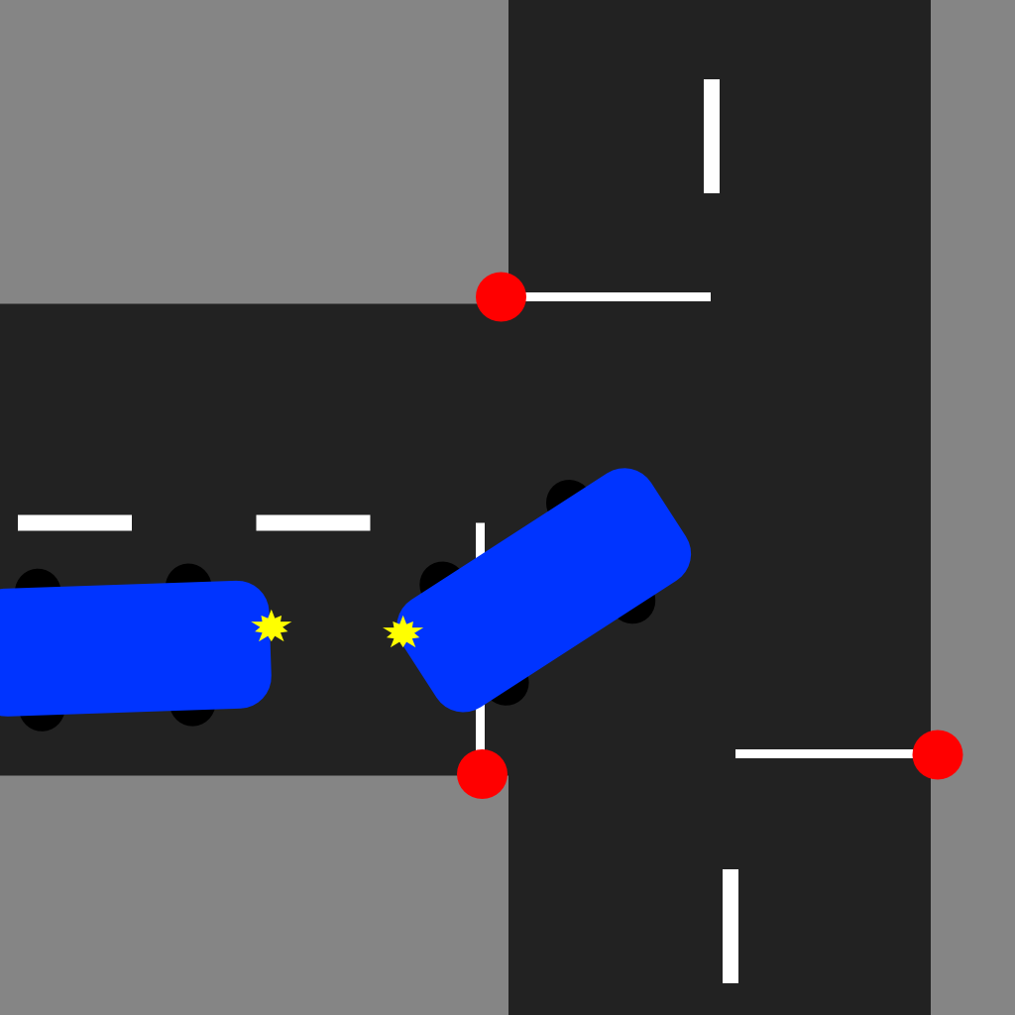

Storyline: Distracted driver - Driver in Hatchback was texting while driving, did not notice car stopped in front at stop sign, hit SUV from behind. Veered slightly to the left before impact. The SUV moved slightly into the intersection after impact.

**Speed at point of impact - ~42km**

**Weather conditions - Clear, Afternoon**

**Date and Time - June 17, 12:05 PM 2020**

Dispatch Call: Attention all units, There has been a rear end collision at the intersection of Grand River Street and Service Road 67. Reported at Municipality of Waterloo, District: **Need sample** Road jurisdiction: **Need Sample**

Name of Offence

**Careless Driving, Follow Too Closely**

Potential Evidence:

SUV rear damage

Hatchback front damage

Skidmarks from attempted stop (hatchback)

Debris from accident

Cellphone

Lisa W. Pena, SUV driver: “I was just stopped at the stop sign, getting ready to make my left when this idiot smashed into me! Probably on their phone or something”

Kyle F. Evans, AUDI Driver: “I literally didn’t even see the car in front of me! The stop sign came up so fast, I didn't expect it.”

Jules Dunkerly, Witness: “I was reading my book on the porch, when I heard a loud bang. I looked up and saw these two cars collided”

**Witness Biography**

Name: Jules Dunkerly

Address: 1 Grand River Rd, L3U 2F4 Waterloo ON

Sex: Female

Birthdate: March 4, 1987

Phone number: 905-888-7777

**Driver Biography (Hatchback)**

Name: Kyle F. Evans

Address: 2166 Lauzon Parkway, Windsor, ON N8Y 4V1

Licence #: E2977-55327-50722

Province: ON

Licence Class: G

Licence Issue Date: 2020/03/16

Licence Expiry Date: 2025/03/16

Condition:

Sex: Male

Birthdate: July 22, 1975

Phone #: 519-965-9466

**Ownership (Hatchback)**

Name: Kyle F. Evans

Address: 2166 Lauzon Parkway, Windsor, ON N8Y 4V1

Year # 2016

Make: Audi

Model: AS3

Plate # HBLW-236

VIN: 1FMFU15L44LA35096

Permit Number: E1453867

Signature of owner:

RIN # (Licence #):

Body Type: Hatchback

Type of Vehicle: (Always Passenger)

**Insurance (Hatchback)**

Year Make Model: 2016 AUDI AS3 Hatchback

Policy # X88816580BGO

Insurance Company: TD Insurance

Phone Number: 1-855-892-0407

Effective date: Nov 24, 2019

Expiry date: Nov 24, 2021

Insurance holder name: Kyle F. Evans

Insurance holder address: 2166 Lauzon Parkway, Windsor, ON N8Y 4V1

**Driver Biography (SUV)**

Name: Lisa W. Pena

Address: 1772 Beaver Creek Dr, Thornhill, ON L4J1W2

Licence #: P0095-45230-10326

Province: ON

Licence Class: G2

Licence Issue Date: 2017/11/25

Licence Expiry Date: 2022/11/25

Condition:

Sex: Female

Birthdate: March 26, 2001 (19 years old)

Phone #: 905 626-8954

**Ownership (SUV)**

Name: Lisa Pena

Address: 1772 Beaver Creek Dr, Thornhill, ON L4J1W2

Year # 2018

Make: Land Rover

Model: Range Rover Evoque

Plate # GVBT-144

VIN: 1GCCS19W9YK245190

Permit Number: P4195169

Signature of owner

RIN # (Licence #):

Body Type: SUV

Type of Vehicle: (Always Passenger)

**Insurance (SUV)**

Year Make Model: 2018 Land Rover Range Rover Evoque

Policy # C57186941KWV

Insurance Company: Belairdirect

Phone Number: 1 888 280 8549

Effective date: 2018, September 2nd

Expiry date: 2020, September 2nd

Insurance holder name: Lisa Pena

Insurance holder address: 1772 Beaver Creek, Thornhill, ON L4J1W2

## Scenario 3 - Head On Collision

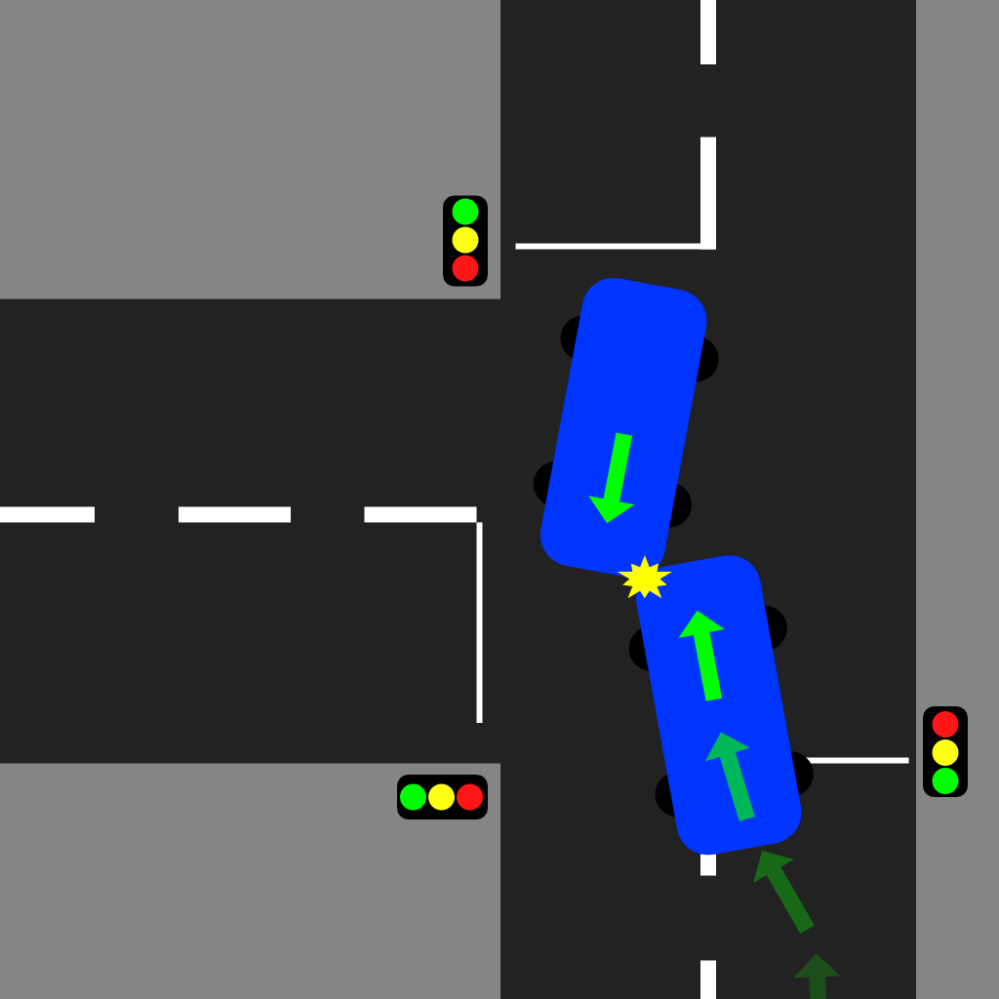

Storyline: SUV Driver applying makeup in mirror, not paying attention to the UPCOMING intersection. The SUV slightly veers to the left and collides with incoming cars. The AUDI reacts and slightly moves to their right but does not move out of the way in time and still collides.

**Speed at point of impact - ~70km**

**Weather conditions - Clear, Morning**

**Date and Time - September 05, 8:30 AM 2020**

Dispatch Call: Attention all units, there has been a head on collision involving 2 vehicles at the intersection of Grand River Street and South Service road 67. Personal injury reported with both drivers transported to Hospital with serious injuries.

Name of Offence

**Careless Driving**

Potential Evidence:

Debris from accident

Skid marks

Airbag deployed in both vehicles

SUV front left damage

AUDI front left damage

Makeup in car in SUV (on seat?)

Yanna Garland, SUV Driver: “I was making my way down the road, as I got through the intersection I was checking my blindspots when I got hit out of nowhere!”

Usha Tirrell, Hatchback Driver: “As I was going through the intersection the other car started drifting into my lane, I thought they might be just making a left hand turn once I passed but then it just crashed right into me!”

Witness 1:

Witness 2:

**Driver Biography (SUV)**

Name: Yanna Garland

Address: 18 Cliffy Drive, Kitchener ON. L1L 2D4

Licence #: G1095-42239-91028

Province: ON

Licence Class: G2

Licence Issue Date: 2019/02/21

Licence Expiry Date: 2024/02/21

Condition:

Sex: Female

Birthdate: Oct 28, 1999 (21 years old)

Phone #: 905-555-1616

**Ownership (SUV)**

Name: Julia Garland

Address: 18 Cliffy Drive, Kitchener ON. L1L 2D4

Plate # XSZM-017

Year # 2018

Make: Land Rover

Model: Range Rover Evoque

VIN: 2QFQQ12W9YK263277

Permit #: G6719305

RIN # (Licence #):

Body Type: SUV

Type of Vehicle: (Always Passenger)

**Insurance (SUV)**

Year Make Model: 2018 Land Rover Range Rover Evoque

Policy # 2169754IRW

Insurance Company: TD Insurance

Phone Number: 1-855-892-0407

Effective date: February 26, 2019

Expiry date: February 26, 2021

Insurance holder name: Julia Garland

Insurance holder address: 18 Cliffy Drive, Kitchener ON. L1L 2D4

**Driver Biography (Hatchback)**

Name: Usha Tirrell

Address: 2020 Tesla Drive, Cambridge ON, L2A 4D4

Licence #: T9090-44447-31205

Province: ON

Licence Class: G

Licence Issue Date: 2016/06/08

Licence Expiry Date: 2021/06/08

Condition:

Sex: Female

Birthdate: December 5, 1973

Phone #: 909-777-9090

**Ownership (Hatchback)**

Name: Usha Tirrell

Address: 2020 Tesla Drive, Cambridge ON, L2A 4D4

Plate # CKIE-341

Year # 2016

Make: Audi

Model: AS3

VIN: 2QCAV12W9YK245189

Permit Number T4640161

RIN # (Licence #):

Body Type: Hatchback

Type of Vehicle: (Always Passenger)

**Insurance (Hatchback)**

Year Make Model: 2016 AUDI AS3 Hatchback

Policy # 53698656SAW

Insurance Company: Belairdirect

Phone Number: 1 888 280 8549

Effective date: November 15, 2018

Expiry date: November 15, 2020

Insurance holder name: Usha Tirell

Insurance holder address: 2020 Tesla Drive, Cambridge ON, L2A 4D4

**Scenarios 1 - 3 will be intended for practice, to allow students to familiarise themselves with the investigation process, and prepare for the final exam simulations.**

## Scenario 4 - Rain, T-Bone Collision

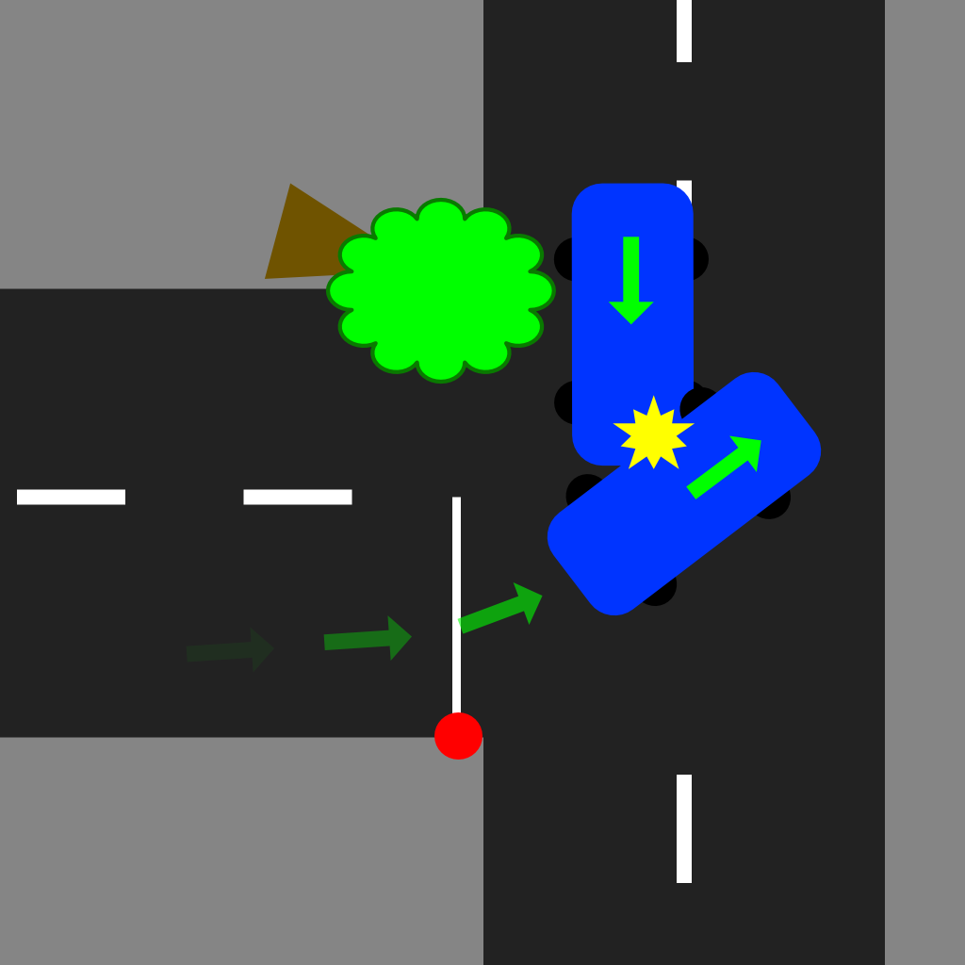

Storyline: Driver is obstructed by a tree that has fallen at the corner of the intersection, blocking the vision of the through road. The SUV is stopped at the stop sign and decides to go, even though they can’t see well enough to safely make the turn. The AUDI reaches the tree and decides to veer around it. T-bone collision occurs in the intersection. Vision is slightly impaired from rain.

**Speed of SUV at point of impact - ~15km**

**Speed of AUDI at point of impact - ~50km**

**Weather conditions - Rain, Evening**

**Date and Time - April 23, 7:15 PM 2020**

Dispatch Call: Attention all units, could you proceed to a two vehicle collision at the intersection of Grand River Street and South Service Road 67. Personal injury reported with one driver transported to Hospital with serious injuries. The other involved driver is at the scene.

Name of Offence

**Fail to Yield to Traffic on Through Highway**

Evidence:

SUV Left Side Damage

AUDI Front Left Damage

Debris from collision

Skid marks

Airbag deployed

Tree that has fallen

Rodger Vossen, SUV Driver: I was turning out of my neighbourhood onto the sideroad. I looked both ways and couldn't see any cars coming. I noticed the tree was down but I couldn't see any car coming behind it. When I took the left onto the sideroad the car came out of nowhere and took me out! I'm not sure how fast he was going but it must've been over the limit as I had no time to react.

Garry Hiram, Hatchback Driver: I was coming along the sideroad when I saw the tree down on the road. I checked behind me and manoeuvred around the tree. As I moved around the tree the other driver peeled out in front of me last second! I had no time to stop or swerve, and did not see the car coming out of that intersection.

**Driver Biography (SUV)**

Name: Rodger Vossen

Address: 21 Trophy st, L9O 1E1 Waterloo ON

Licence #: V0909-87729-40128

Province: ON

Licence Class: G

Licence Issue Date: 2015/02/12

Licence Expiry Date: 2020/02/12

Condition:

Sex: Male

Birthdate: Jan 28, 1994

Phone #: 519 - 555 - 3333

**Ownership (SUV)**

Name: Rodger Vossen

Address: 21 Trophy st, Waterloo ON L90 1E1

Plate # KOZO-658

Year # 2018

Make: Land Rover

Model: Range Rover Evoque

VIN: 6SSWR12W9YK245158

Permit Number: V2954814

RIN # (Licence #):

Body Type: SUV

Type of Vehicle: (Always Passenger)

**Insurance (SUV)**

Year Make Model: 2018 Land Rover Range Rover Evoque

Policy # 3369754YWP

Insurance Company: INTACT insurance

Phone Number: 1-866-464-2424

Effective date: March 29 2018

Expiry date: March 29 2020

Insurance holder name: Rodger Vossen

Insurance holder address: 21 Trophy st, L9O 1E1 Waterloo ON

**Driver Biography (Hatchback)**

Name: Garry Hiram

Address: 22 Chicopee crescent. G1A 0Z1 Montreal, Quebec

Licence #: H6767-09097-00312

Province: Qc

Licence Class: 5 (G for Quebec)

Licence Issue Date: 2020/02/18

Licence Expiry Date: 2025/02/18

Condition:

Sex: Male

Birthdate: March 12, 1970

Phone #: 905-999-1000

**Ownership (Hatchback)**

Name: Garry Hiram

Address: 22 Chicopee crescent. G1A 0Z1 Montreal, Quebec

Plate # MOC-185

Year # 2016

Make: Audi

Model: AS3

VIN: K41SA12W9YK245154

Permit Number: H0184842

RIN # (Licence #):

Body Type: Hatchback

Type of Vehicle: (Always Passenger)

**Insurance (Hatchback)**

Year Make Model: 2016 AUDI AS3 Hatchback

Policy # 63149844SYS

Insurance Company: Desjardins Insurance

Phone Number: 905 641 8888

Effective date: 2019/06/16

Expiry date: 2020/06/16

Insurance holder name: Garry Hiram

Insurance holder address: 22 Chicopee crescent. G1A 0Z1 Montreal, Quebec

## Scenario 5 - Night, Pedestrian Hit

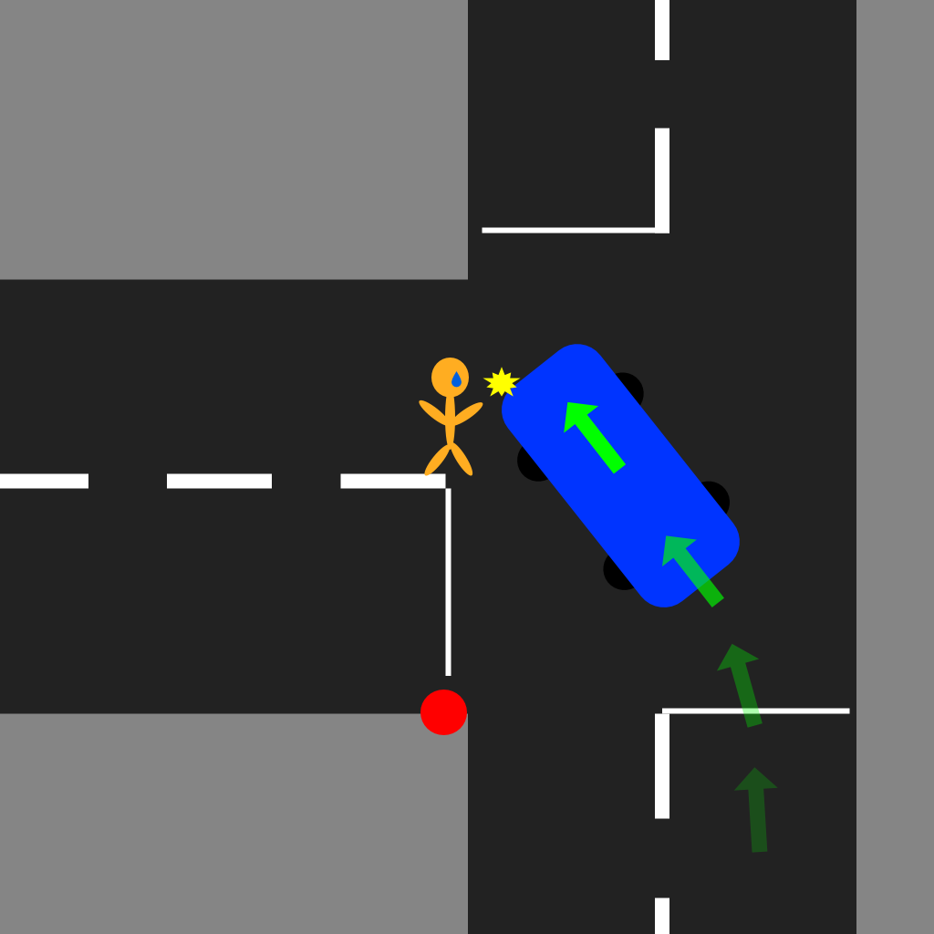

Storyline: Night time, Driver takes a left without paying close enough attention to the pedestrian. The Pedestrian also starts crossing the road without looking both ways. Collision occurs.

**Speed of SUV at point of impact - ~30km**

**Weather conditions - Clear , Night**

**Date and Time - August 27, 9:00 PM 2020**

Dispatch Call: Attention all units, a pedestrian has been struck by a vehicle at the intersection of Grand River Street and South Service road 67. Paramedics have taken the pedestrian to Grand River Hospital. Pedestrian is in stable condition.

Name of Offence

**Improper Left Turn, Careless Driving**

Potential Evidence:

Debris from accident

Skid marks

Blood on ground

Blood on car

Shoe

Paramedic Paraphernalia

NOTE; driver needs glasses

Carlton Bentley, Witness: I heard tires squealing while I was putting the dishes away, I quickly ran outside and saw the pedestrian on the ground. I asked if they needed help and offered to call 911. That's when I made the call and waited here for the paramedics to arrive.

Bryan Almers, SUV Driver (Cautioned): I came up to my turn and took the left onto Grand River when the person came out of nowhere. They must’ve been on a run or something because I didn't see anyone when I was approaching the intersection, and by the time I saw them in my headlights it was too late!

**Witness Biography**

Name: Carlton Bentley

Address: 1 Grand River Rd, L3U 2F4 Waterloo ON

Sex: Male

Birthdate: March 4, 1987

Phone number: 905-888-7777

**Driver Biography (SUV)**

Name: Bryan Almers

Address: 38 Coffee lane, L3U 2D3 Waterloo ON

Licence #: A1919-56566-40106

Province: ON

Licence Class: G

Licence Issue Date: 2019/12/22

Licence Expiry Date: 2024/12/22

Condition: Glasses

Sex: Male

Birthdate: Jan 06, 1964

Phone #: 905 - 444 - 2222

**Ownership (SUV)**

Name: Bryan Almers

Address: 38 Coffee lane, L3U 2D3 Waterloo ON

Plate # UREN-783

Year # 2018

Make: Land Rover

Model: Range Rover Evoque

VIN: 6KKLR12Y8YK245136

Permit #: A9609192

RIN # (Licence #):

Body Type: SUV

Type of Vehicle: (Always Passenger)

**Insurance (SUV)**

Year Make Model: 2018 Land Rover Range Rover Evoque

Policy # 9869732YXK

Insurance Company: INTACT insurance

Phone Number: 1-866-464-2424

Effective date: 2020/05/19

Expiry date: 2022/05/19

Insurance holder name: Bryan Almers

Insurance holder address: 38 Coffee lane, L3U 2D3 Waterloo ON

#### Environment 2

## Scenario 6 - Single Car, Dawn, Collided with guardrail

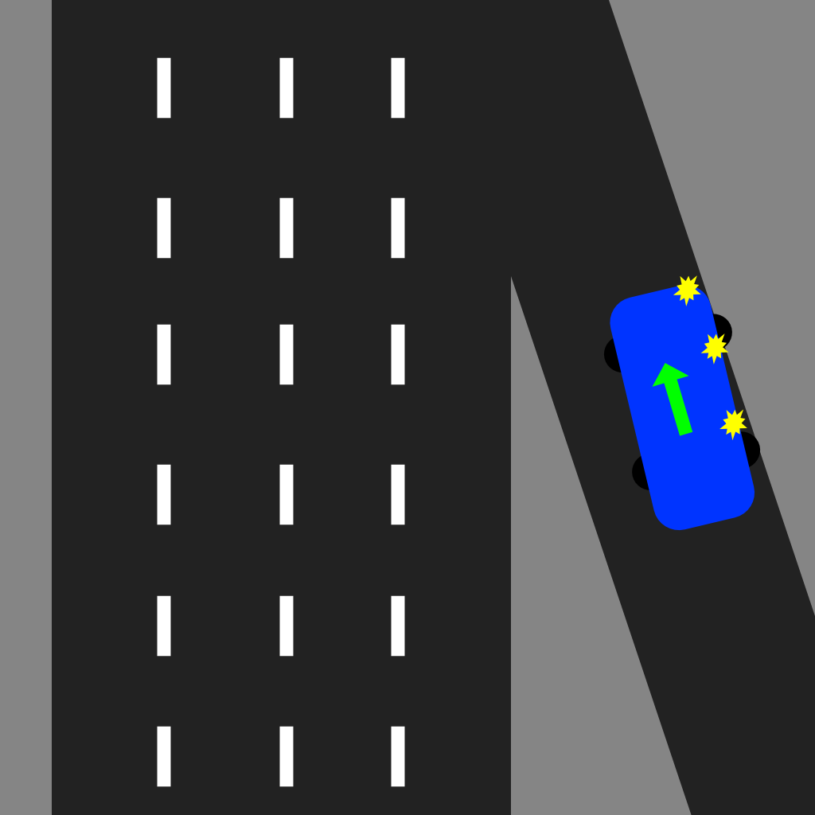

Storyline: Early morning (just after dawn), a single Driver falls asleep at the wheel whilst travelling to work along the on-ramp . This results in a loss of control and an impact/collision with the guardrail. Thankfully, no injuries have occured. Small stretch of highway as well as on-ramp closed temporarily.

**Speed at point of impact - ~50km/hr**

**Weather conditions - Clear, Morning (Dawn)**

**Date and Time - July 2nd, 6:30 AM 2020**

Dispatch Call: Attention all units, a driver has collided with the guardrail heading down the on-ramp at King Street heading 86 South. The driver has experienced shock but thankfully no injuries of any kind are present. Vehicle remains on the on-ramp, proceed with caution.

Name of Offence

**Careless/Reckless driving, distracted driving**

Potential Evidence:

Debris from collision

Damage to vehicles passenger side doors

Damage to passenger side headlight

Damage to guardrail

Skid marks

Case of energy drinks in the passenger seat footwell

NOTE: Driver suffers from Insomnia (apart of unlockable CMT dialogue)

Shawn Boateng, Driver: “I’m not exactly sure how this happened Officier, to be completely honest with you. One minute I’m driving to work, the next minute I’m trying to pull my vehicle away from the guardrail. It’s like I lost control of the steering somehow? Now I’m not too knowledgeable about mechanics, though maybe the brakes or steering are broken somehow?”

**Driver Biography**

Name: Shawn Boateng

Address: 12 Trophy st, L9O 1E2 Waterloo ON

Licence #: S0809-86518-30118

Province: ON

Licence Class: G2

Licence Issue Date: 2016/02/12

Licence Expiry Date: 2020/02/12

Condition:

Sex: Male

Birthdate: Feb 06, 2001

Phone #: 519 - 565 - 3434

**Ownership**

Name: Louise Boateng

Address: 12 Trophy st, L9O 1E2 Waterloo ON

Plate # C1SO-658

Year # 2016

Make: Audi

Model: AS3

VIN: E31TA12U8YK245154

Permit Number: H0184842

RIN # (Licence #):

Body Type: Hatchback

Type of Vehicle: (Always Passenger)

**Insurance**

Year Make Model: 2016 AUDI AS3 Hatchback

Policy # 54238735SYS

Insurance Company: Desjardins Insurance

Phone Number: 905 441 8818

Effective date: 2019/07/18

Expiry date: 2021/02/06

Insurance holder name: Louise Boateng

Insurance holder address: 12 Trophy st, L9O 1E2 Waterloo ON

## Scenario 7 - High Speed sideswipe, Snow/Black ice

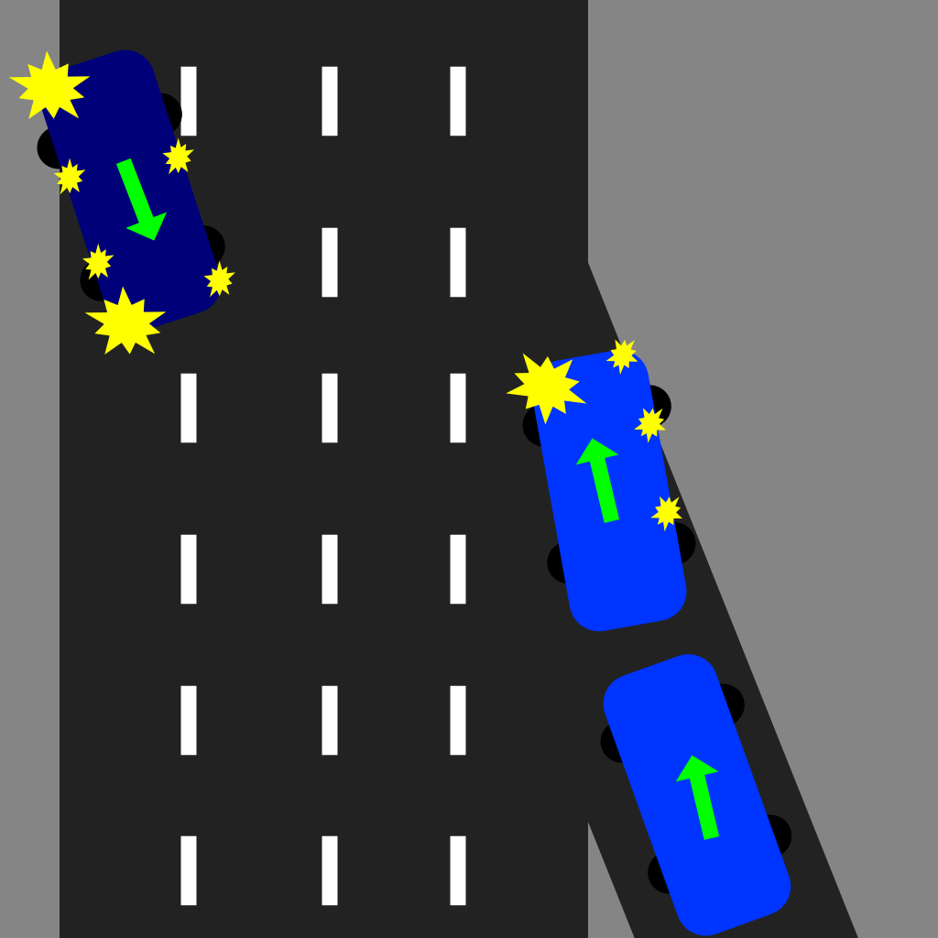

Storyline: An SUV driver travelling well over the speed limit down the on-ramp, hits black ice. This causes it to start merging unintentionally. This results in a pick up truck clipping the driver side of the SUV’s nose which sends it barreling down the freeway, many lanes across towards the express lane’s guardrail. The pickup driver had to be rushed to hospital in critical condition, the SUV driver has just finished medical checks and is ready to talk. There is also a witness who was another pick up driver behind the SUV.

**Speed at point of impact - ~85km**

**Weather conditions - Snow, Morning**

**Date and Time - Jan 28th, 10:15 AM 2020**

Name of Offence

**Failed to drive on marked lane, reckless driving**

Potential Evidence:

Skidmarks

All airbags deployed

Damage to SUV  
Damage to Pick Up

Damage to Guardrails

Witness account

Dispatch Call: Attention all units, we need you to respond to a two-car vehicle collision on the on- ramp at King Street heading 86 South ASAP. An SUV has appeared to have slid down the on-ramp and prematurely merged, clipping a pickup truck that then barreled across 4 lanes, and is now upside down 30km down the highway. One driver in critical condition on route to Grand River ER.

Mary-Ann M. Kovacs, Driver (Cautioned): “I was coming down the on-ramp at…*pause*...normal speeds I’d say and then all of a sudden I’m sliding and drifting towards a pickup in my blindspot! I feel terrible about the poor man in the truck. I really hope he’s going to be okay, do you think that he’s going to be okay?! Please I don’t know what happened, I’m just so scared and confused!”

Karen Stevens, Witness: “I saw everything. Oh, please tell me that young man is going to be okay! I saw his Licence plate, he’s from out of province I think. Please tell me you’re going to arrest that reckless asshole! I’m sorry, it’s just that some people don’t know not to drive stupid, especially when there is black ice everywhere!”

**Driver Biography (SUV)**

Name: Mary-Ann Kovacs

Address: 534 Clair Creek Blvd, L9O 1A3 Waterloo ON

Licence #: O0094-70885-50129

Province: ON

Licence Class: G

Licence Issue Date: 2016/05/11

Licence Expiry Date: 2021/05/11

Condition:

Sex: Female

Birthdate: May 11, 1960

Phone #: 905 - 617 - 9832

**Ownership (SUV)**

Name: Mary-Ann Kovacs

Address: 534 Clair Creek Blvd, L9O 1A3 Waterloo ON

Plate # GSLQ-887

Year # 2018

Make: Land Rover

Model: Range Rover Evoque

VIN: JG2IT5FEJ82678

Permit Number: O7862118

RIN # (Licence #):

Body Type: SUV

Type of Vehicle: (Always Passenger)

**Insurance (SUV)**

Year Make Model: 2018 Land Rover Range Rover Evoque

Policy # 9869732YXF

Insurance Company: TD Insurance

Phone Number: 905 - 617 - 9832

Effective date: 2020/05/19

Expiry date: 2022/05/11

Insurance holder name: Mary-Ann Kovacs

Insurance holder address: 534 Clair Creek Blvd, L9O 1A3 Waterloo ON

**Driver Biography (Pick Up)**

Name: John Walsh

Address: 502 Water St, A1E 1B6 St. John’s NL

Licence #: W920612937

Province: NL

Licence Class: 5 (G for Newfoudland)

Licence Issue Date: 2016/11/11

Licence Expiry Date: 2021/11/11

Condition:

Sex: Male

Birthdate: June 12th, 1992

Phone #: 709 - 617 - 9733

**Ownership (Pick Up)**

Name: John Walsh

Address: 502 Water St, A1E 1B6 St. John’s NFLD

Plate # AUT-877

Year # 1988

Make: Toyota

Model: Hilux

VIN: JG2IT5FEJ82677

Permit Number: O7862117

RIN # (Licence #):

Body Type: Pick Up

Type of Vehicle: (Always Passenger)

**Insurance (Pick Up)**

Year Make Model: ???

Policy # 6871131YXF

Insurance Company: TD Insurance

Phone Number: 709 - 617 - 9733

Effective date: 2019/07/01

Expiry date: 2021/06/12

Insurance holder name: John Walsh

Insurance holder address: 502 Water St, A1E 1B6 St. John’s NFLD

## Scenario 8 - Rear End, Evening, Distracted driving

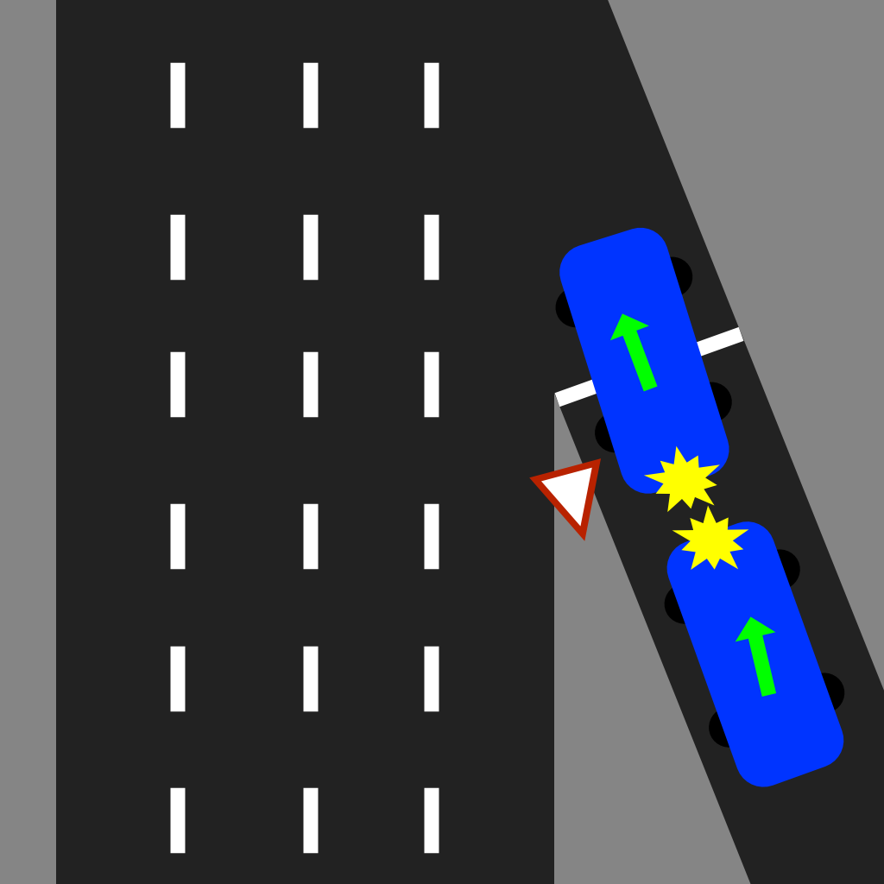

Storyline: A Hatchback driver travels over the speed limit down the on-ramp while eating food and texting. This causes them to not notice a pick up truck yielding and waiting to merge resulting in the hatchback rear ending the pick up truck. Both drivers are recovering from shock. The pick up truck driver experienced slight whiplash and is quite understandably irritated. Also there is a smell of cannabis in the air around the collision as a red herring.

**Speed at point of impact - ~55km**

**Weather conditions - Sunny, Noon**

**Date and Time - Aug 18th, 12:15 PM 2020**

Name of Offence

**Distracted driving, Reckless Driving**

Potential Evidence:

Skidmarks

All airbags deployed

Damage to Hatchback  
Damage to Pick Up

Food, cell phone, and wireless earbuds scattered in drivers footwell

Damage to guard rail

Dispatch Call: Attention all units, we need you to respond to a two-car collision on the on- ramp at King Street heading 86 South ASAP. A hatchback has appeared to have rear ended a pick up truck yielding to merge. The pick up truck driver is experiencing neck pains. Both vehicles are in park along the on-ramp and please approach with caution.

Sebastian Gomez, Driver (Cautioned): “I was heading down the on-ramp when all of a sudden an old water bottle rolled underneath my pedals and when I got back up from grabbing it all I saw was the truck’s tailgate. I didn’t even see the truck before that man I swear!”

Chin Yang, Driver (irritable): “He was texting and eating. I saw him in my rear view mirror right before the asshole hit me. My neck and face are killing me, I just want this to be over with! This is my side of the story, so please take your statement and let me get home or to a doctor or something…and take that asshole’s licence away please. Do something to fix this!”

**Driver Biography (Pick Up)**

Name: Chin Yang

Address: 515 Willow Wood Dr, L9O 1A3 Waterloo ON

Licence #: Y1562 - 83308 - 50511

Province: ON

Licence Class: G

Licence Issue Date: 2017/03/20

Licence Expiry Date: 2022/03/20

Condition:

Sex: Female

Birthdate: May 11, 1985 1985/05/11

Phone #: 905 - 732 - 2549

**Ownership (Pick Up)**

Name: Chin Yang

Address: 515 Willow Wood Dr, L9O 1A3 Waterloo ON

Plate # TOXO-451

Year # ???

Make: ???

Model: ???

VIN: 2DEWR12W9YK215156

Permit Number: H2814184

RIN # (Licence #):

Body Type: Pick Up

Type of Vehicle: (Always Passenger)

**Insurance (Pick Up)**

Year Make Model: ???

Policy # 2268754AWP

Insurance Company: INTACT insurance

Phone Number: 905 - 888 - 9136

Effective date: June 01 2019

Expiry date: May 11 2021

Insurance holder name: Chin Yang

Insurance holder address: 515 Willow Wood Dr, L9O 1A3 Waterloo ON

**Driver Biography (Hatchback)**

Name: Sebastian Gomez

Address: 54 Dietz Ave S, N2L 2J9 Waterloo ON

Licence #: A0807-16612-21928

Province: ON

Licence Class: G

Licence Issue Date: 2016/02/16

Licence Expiry Date: 2021/02/16

Condition:

Sex: Male

Birthdate: Jan 28, 1994

Phone #: 905 - 514 - 3222

**Ownership (Hatchback)**

Name: Sebastian Gomez

Address: 54 Dietz Ave S, N2L 2J9 Waterloo ON

Plate # ARTT-141

Year # 2016

Make: Audi

Model: AS3

VIN: V38SB52W9YK425156

Permit Number: J0164861

RIN # (Licence #):

Body Type: Hatchback

Type of Vehicle: (Always Passenger)

**Insurance (Hatchback)**

Year Make Model: 2016 AUDI AS3 Hatchback

Policy # 91238646SGW

Insurance Company: Belairdirect

Phone Number: 1 888 280 8549

Effective date: November 28, 2016

Expiry date: January 28, 2022

Insurance holder name: Sabrina Gomez

Insurance holder address: 2024 Tesla Drive, Cambridge ON, L2A 4D3

CONDITIONS :

A Special hand controls required

B Special foot controls required

C Special controls for hand and foot required

D Hearing device required

E Visual device required

F Driver training conditions

G Restricted ClassIIgnition Interlock required

J Special name/address requirements exist

K Special controls required

L Can only drive Limited-speed motorcycles and motor assisted bicycles

M Restricted motorcycle

N Hearing device required when operating Class A or D vehicle in U.S.

R Class A vehicle restriction (cannot tow two trailers or a trailer equipped with air brakes)

S For test use only

V Valid for rehab evaluation only

W Can only drive a commercial vehicle in Canada only

**X Must have corrective lenses**

Z Can drive a vehicle equipped with air brakes

2(HC) Hand controls

+ Indicates more conditions/restrictions of lesser priority exist - requires system check.

Things to consider for rest of scenarios:

* Out of province Licence (4)
* Different driver from ownership/insurance (3)
* Driver condition (Glasses/breathalyser) (5)
* Different Licence class (2)
* Expired Licence
* Other passengers

### 3D Asset list

#### Pickup truck (Sourced then modified by modeller)

New vehicle type Pickup Truck though the make, model, and year are undetermined at this moment. Used in Scenarios 7 and 8. A few reference images:

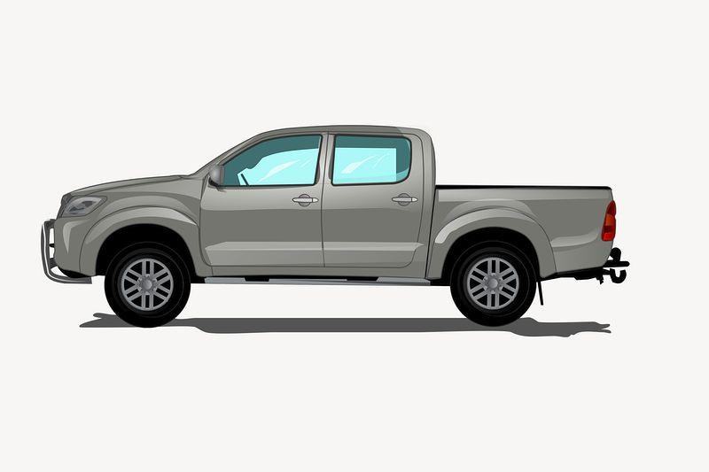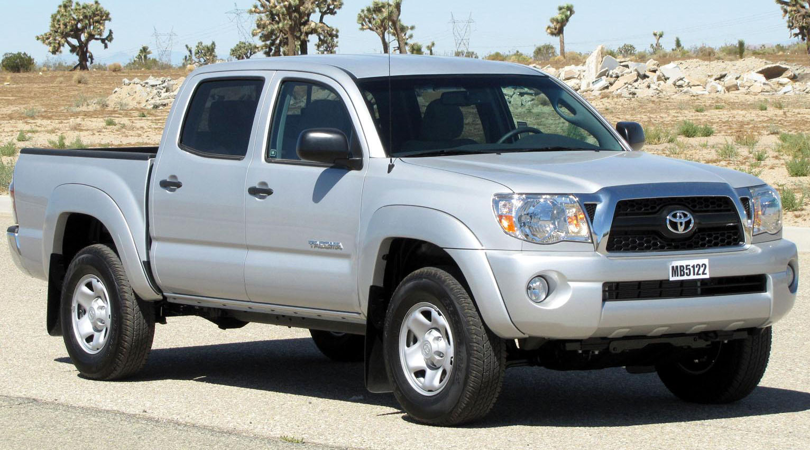

#### Yield Sign (Modelled)

Static 3D model of a yield sign for use in scenario 8. Reference images:

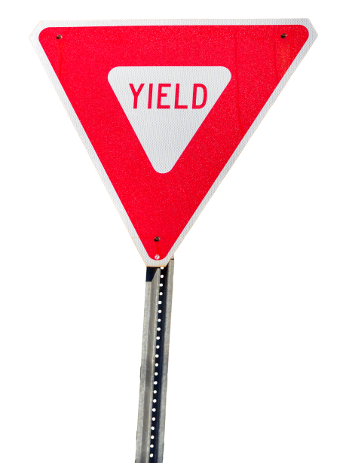

#### Empty Water Bottle (Modelled)

Related to a witness statement S8. Static 3D model of empty water bottle, Reference images:

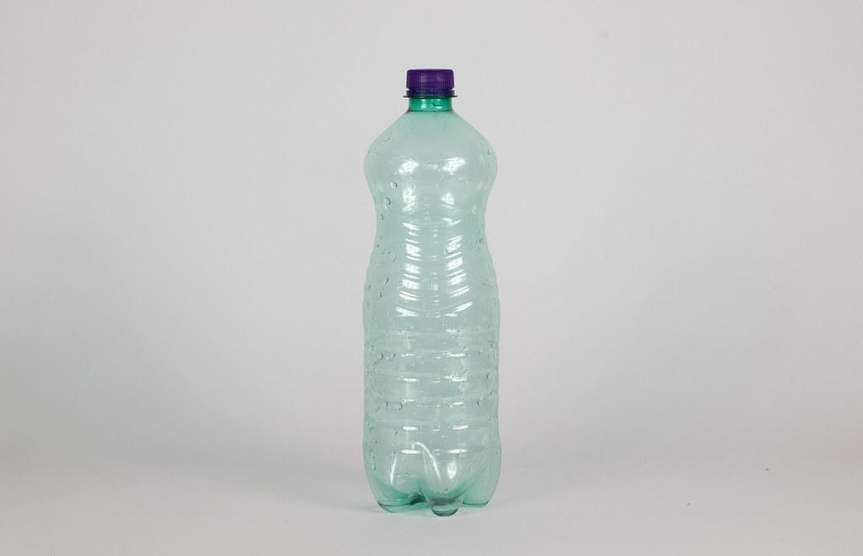

#### Fast food bag half eaten scattered across a flat surface (Modelled)

Related to a witness statement S8. Static 3D model of a fast food bag that’s been half eaten and tipped over within the driver side footwell. Reference images:

### 

### 

### 

### 

### Loose and multi-packaged energy cans (Modelled)

Related to a witness statement S6. Static 3D model of loose and packaged cans of energy drinks. Reference images:



### Ready Player Me characters

3D character models to represent each/every driver and witness involved in each scenario Reference images:

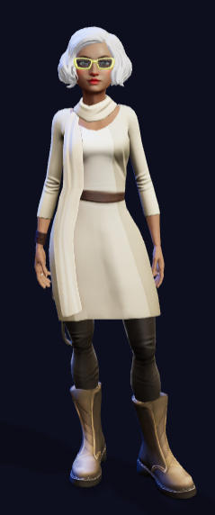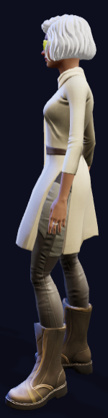

### Sound FX

#### **Voice Lines**

**[Work in Progress - once interview scripts are written this doc will be updated]**

[Voice Line Document Template](https://docs.google.com/document/d/1eT43jKZv8htuVz0XOvS5iE_5wSv4HDe0DZIFeKb_LiI/edit#)

#### Loud highway track

3D looping track that increases in volume the closer you get to the freeway.

#### Button press sound effect

Audio feedback sound effect for users whenever they interact with UI buttons. This sound effect will be monotone and dampened to create a subtle yet recognizable hum noise for more tactile UX.

#### Damaged truck noises

3D looping sound effect whenever users are near damaged pickup trucks.

#### General RPM character noises

To create a sense of presence with each RPM character in each scenario, it’s important that whenever RPM characters are standing/waiting in an idle animation they should be making some quiet noises to themselves periodically as well as whenever they animate.

### UX/UI Design

The UX/UI design for both *Conestoga Traffic Uplift* and *Conestoga Crime Uplift* will be as similar as possible to ensure a sense of uniformity between all Conestoga policing training simulations. Colour scheme, fonts, button sizes and placement, along with visual, audio, and haptic feedback will all be considered and utilised to create a seamless and fluid feeling UI and menu UX. There will exist a persistent exit simulation button as well as an option to adjust various user settings. Menu systems will ultimately be used to collect player data and for scenario selection as well as persistent simulation termination capabilities.

#### Main Menu

See wireframe example using the hyperlink below. This is a basic breakdown of the menu UI pages and their respective button layouts and functionalities.

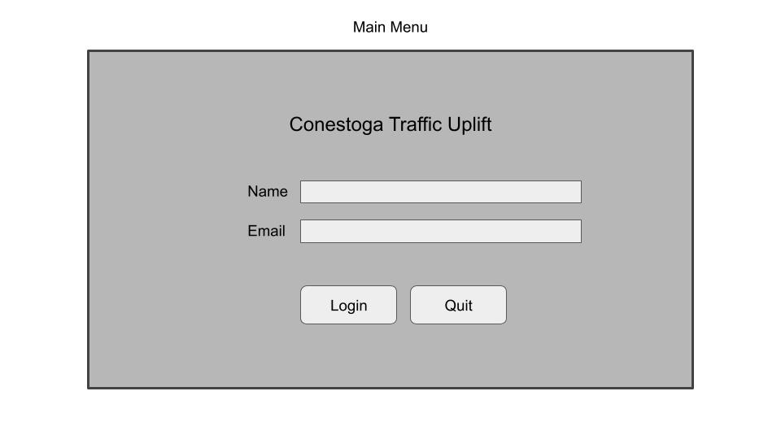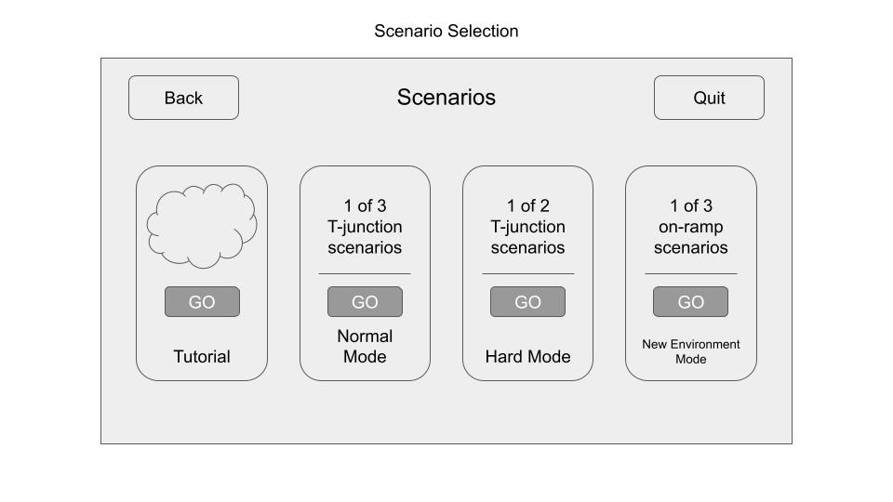

#### CMT Tablet UI

The in-game tablet which is used to access the measurement tool and camera will now also be used to instigate and participate in CMT RPM character dialogue. All potential dialogue options will appear as buttons within a page of the tablet under the “CMT” page.

## Technical Design

### Unlockable Information System

*Scripts & Public Variables / Methods*

*This system contains a pool of questions that can be enabled or disabled by certain events like collecting a piece of evidence or talking to an NPC. A special node for our in-house Conversation Matrix Tool will be created to enable the display and handling of these questions in the UI.*

* *QuestionPool.cs*
  + *Contains and manages questions.*
  + *CSIQuestion[ ] questions*
    - *The array of questions.*
  + *Public void ToggleQuestion(int index, bool state)*
    - *Enables/disables a question at the given index.*
  + *Public string GetQuestion(int index)*
    - *Returns the question text at the given index. Returns empty (““) if the question is disabled.*
  + *Public string[] GetQuestions()*
    - *Returns the questions as a string array. Disabled questions are listed empty (““).*
  + *Struct CSIQuestion*
    - *string questionText*
      * *The text of the question.*
    - *bool isEnabled*
      * *The status of the question.*
* *QuestionPoolNode.cs*
  + *A special node for the in-house Conversation Matrix Graph Tool. This node will display the enabled questions in the question pool via Conversation Matrix Graph Player UI.*
  + *int input*
    - *Previous node.*
  + *Int output*
    - *NextNode*

### Menu System

*Script & Public Variables / Methods*

*What you want to do here is list out the scripts that will be written and list out the useful public variables/methods that will be accessible by other scripts. Additionally, describe how this system may work with additional scripts and how they will be used.*

* *Script.cs*
  + *int countOfSomething*
    - *This could be an integer that counts something*
  + *float specificValue*
    - *This could be a float that is used for a setting that needs to be public*
  + *UpdateFloat(float value)*
    - *This will update a float to a value*
* *Script2.cs*
  + *int countOfSomething*
    - *This could be an integer that counts something*
  + *float specificValue*
    - *This could be a float that is used for a setting that needs to be public*
  + *UpdateFloat(float value)*
    - *This will update a float to a value*

### XpertAPI for Traffic Uplift PC

*Scripts & Public Variables / Methods*

*This system contains all necessary scene loading and player data storage/collection throughout each and every scenario and is persistently active. It also allows developers to load and test any scene without first navigating through the main menu UI.*

* *SimulationManager.cs*
  + *Contains and manages all scene loading.*
  + *EventManager[ ]* 
    - *The array of timestamps and event strings.*
  + *TimeManager*
    - *Manages timers and time events*
  + *EmailManager*
    - *Handles saving user email and sends event data after a scenario is completed*
  + *DebugManager*
    - *Acts as SimulationManager through Polymorphism whenever active in a scene/scenario when a SimulationManager is missing and therefore allows developers to begin testing any scene as soon as possible*
  + *LevelManager*
    - *A non-persistent manager that exists within each and every different scenario to keep track of objects, assets, and scene functionality*

## Schedule & Deliverables: Project Name

### Asset Creation

Whitebox new environment

* + Creating 3D layout of the scenario collisions

Environment assets

* + Static objects to fill the scene
  + Evidence pieces
  + 13+ RPM characters

Interactable objects

* + RPM interactions through CMT
  + Unlockable dialogue evidence

### Programming & Technical Art

Technical Artwork

* + Scaling/sizing, Material Optimization, Lighting, visual FX

System creation

* + Game Flow, Scene Transitions, Persistent data, Locomotion (PC/VR), Information Export, new CMT for investigation

UX

* + Sound Design, UI, Interactable Objects Information Display, haptic feedback

Gameplay Optimization

* + Build for both PC (Mouse & Keyboard) and the HTC Vive Cosmos

### Milestones

**We anticipate a project timeline of: 5 months With a routine check-in every: 2-4 weeks**

Milestone 1: Confirm all required materials to begin development - Week of 08/12/22

XpertVR Traffic Uplift QA testing & bug tracking week 1 - Week of 10/24/22

Milestone 2: 3D Environment Delivered - Week of 10/28/22

XpertVR Traffic Uplift QA testing & bug tracking week 2 - Week of 11/14/22

Milestone 3: Final build delivered - Week of 12/16/22

## Project Uncertainties and Risks

| Uncertainties | Uncertainty Mitigation | Risks | Risk Mitigation |
| --- | --- | --- | --- |
| How well will the new scenarios and environment fit in with the rest of the sim. | Constant sprint and in-house QA playtests will help ensure fluidity between scenarios | New unlockable system for CMT and first time use | Two full time developers using it asymmetrically but in constant communication |
| If the new highway environment will fit the pedagogical considerations of the simulation | Meeting and confirming details with content experts at each meeting | RPM characters creating a sense of uncanny valley | Sound design/FX, animations (body language and facial expressions), as well as voice lines |
| The naming and organisation of scenarios and their respective sections (normal, hard, etc.) may not longer fit the pedagogical specifications of the uplift project | Client and content expert meetings will help to establish a different/better way to name and/or organise scenarios into sections |  |  |
| Scenario 3 has no one to interview as both drivers were rushed to the ER | Discuss possible development solutions with content experts |  |  |
| We still need to ensure that the CE’s and clients like that questions can’t be asked multiple times (are removed after asking) | Ask them |  |  |